1. Introduction
The Precision Anatomy Telemetry & Consultation Portal (Doctors' Call) is a modern telehealth platform designed to bridge physical diagnostic coordinate mapping with clinician consultation routers.
Project Metric | Details / Declarations
Project Title | Precision Anatomy Telemetry & Consultation Portal (Doctors' Call)
Lead Developer & Architect | Tej Rohit Paruchuri
Core Function | Visual anatomical symptom coordinate mapping with time-decaying session controls
Team ID

2. Project Overview
The portal provides an interactive visualization layer connecting patients experiencing physical pain with verified medical specialists. Below is a structured representation of the core modules:
Module Name | Primary Feature & Description
Anatomy Scanner | SVG interactive vector map interface allowing users to lock cursor coordinates on bone, muscle, or organ layers.
Specialist Hub | Multi-variable roster search matching coordinates to specific disciplines with location and rate sliders.
Checkout Pipeline | Automated transaction calculations displaying platform fees, payouts, and standard 18% medical tax.
Decaying Sessions | Active session timers that expire consultation access exactly 48 hours post-checkout or after 2 call entries.

3. Architecture
The architecture follows a standard 3-tier MERN stack model for clean segregation of presentation logic, application routing, and data models:
Architecture Tier | Technology Framework | Role & Description
Frontend Presentation | React.js SPA (Vite Compiler) | Handles interactive vector maps, ambient dark layouts, and active countdown clocks.
Backend Application | Node.js & Express.js API | Coordinates routing controllers, verifies credentials, hashes security access keys, and outputs billing ledgers.
Database Storage | MongoDB & Mongoose ODM | Provides persistent storage for users accounts, clinician schedules, and payment timer collections.

4. Setup Instructions
Set up the development and execution environments using the configurations outlined below:
Prerequisite / Setup Step | Command / Configuration Details
Software Pre-requisites | Node.js (v18.0.0+), npm packages registry, MongoDB Community Server
Database Connection | mongodb://localhost:27017/doctorscall (Running locally on default port)
Server Dependencies Setup | cd backend && npm install (Installs Express, Mongoose, Bcrypt, JWT, Cors)
Client Dependencies Setup | cd frontend && npm install (Installs React Router DOM, Axios)
Server Environment Settings | Declare PORT=5000 and JWT_SECRET=securekey inside local .env file

5. Folder Structure
The repository is divided into distinct frontend client modules and backend server components:
Directory Location | Folder / File Path | Structural Role & Description
React Client Frontend | /frontend/src/components | Houses reusable UI elements such as layout headers and custom inputs.
React Client Frontend | /frontend/src/pages | Contains dashboard views (Home, Profile, Register, Session, Call).
React Client Frontend | /frontend/src/App.jsx | Client-side routes configuration mapping components.
Express Backend Server | /backend/models | Defines MongoDB data schemas (User.js, Doctor.js, Appointment.js).
Express Backend Server | /backend/controllers | Implements API controller logic (DoctorController.js, AdminController.js).
Express Backend Server | /backend/server.js | Launches DB connector instance and binds listener on port 5000.

6. Running the Application
Use these standard commands inside concurrent terminal sessions to start the application layers:
Application Layer | Startup Working Directory | CLI Startup Command
Client Frontend Console | /frontend | npm start
Server Backend API | /backend | npm start

7. API Documentation
The backend exposes a REST API with routing controllers managing authentication, searches, checkouts, and sessions:
Method | URI Endpoint | Payload / URL Params | Response Status & Output
POST | /api/users/register | { email, password, fullName, phone, type } | 201 Created - returns confirmation message
POST | /api/users/login | { email, password } | 200 OK - returns Signed JWT verification token
GET | /api/doctors | Optional: ?city=city_name&rates=max_rate | 200 OK - lists matching clinician profiles
POST | /api/appointments/checkout | { doctorId, billingDetails } | 201 Created - saves token and session metadata
GET | /api/appointments/session/:id | Active session reference ID | 200 OK - retrieves active session countdown decay status

8. Authentication
Authentication checks are processed through layered encryption protocols:
Security Component | Mechanism | Operational Purpose
Password Encryption | Bcrypt Hashing (10 Salt Rounds) | Salts and hashes credentials before saving to the User model.
Endpoint Authorization | JSON Web Tokens (JWT) | Attaches token headers to authorization queries to identify patient/specialist sessions.
Session Access Lock | JWT Controller Interceptor | Rejects client connection queries if JWT signature check is invalid or missing.

9. User Interface
The interface utilizes an ambient dark themed dashboard for clear visual focus. The core UI modules allow patients to interact with the anatomical coordinate locator, sort doctor profiles, checkout invoices, and track session decay clocks. Clinicians access active call profiles and configure consultation details.

10. Testing
Verify implementation endpoints and layouts using these verification methods:
Test Category | Validation Method | Expected Outcome Metric
Auth Verification | Register client profiles with validation checks | Hashed credentials saved; JWT returned on valid login.
Telemetry Routing | Click bones/organs on SVG anatomical map | Coordinates lock successfully and filter roster to matching domain.
Checkout Tax Check | Trigger checkout pipeline invoice calculations | Invoice details standard 18% medical tax component and fee splits.
Countdown Decay | Access consultation endpoints 48 hours post-checkout | Authorization is revoked; session expires automatically.

11. Screenshots or Demo
Below are the layout result screens detailing the full set of user interfaces in the Doctors' Call system:

Result Image: Platform Landing Page

The main landing page of the Precision Anatomy Telemetry & Consultation Portal presents a highly professional, dark-themed user interface designed to maximize clinical usability. It features clear navigation hooks for the Anatomy Scanner, Doctors' Hub, active Sessions, and user Profiles, establishing the gateway for all patient-clinician telemetry operations. The left-aligned layout utilizes a distinct branding element and offers brief introductory descriptions to ensure seamless user onboarding, aligning with modern digital healthcare standards.

Result Image: Clinician & Patient Registration Interface
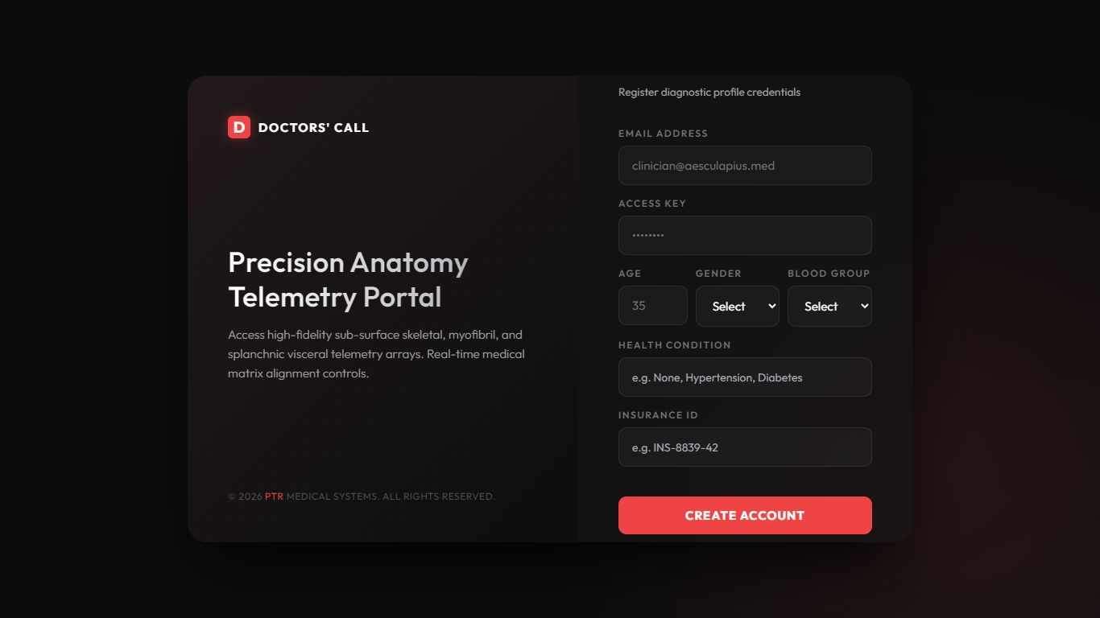
The registration interface allows users to enroll in the Doctors' Call system by entering their email address, security access keys, and demographic credentials such as age, gender, and blood group. The profile registration captures critical diagnostic metrics, including reported health conditions and Insurance IDs, which are later indexed by the matching router. Hashed passwords and JWT tokens are generated on the server backend to secure these credentials, adhering to HIPAA and standard clinical security protocols.

Result Image: Secure Access Verification Portal
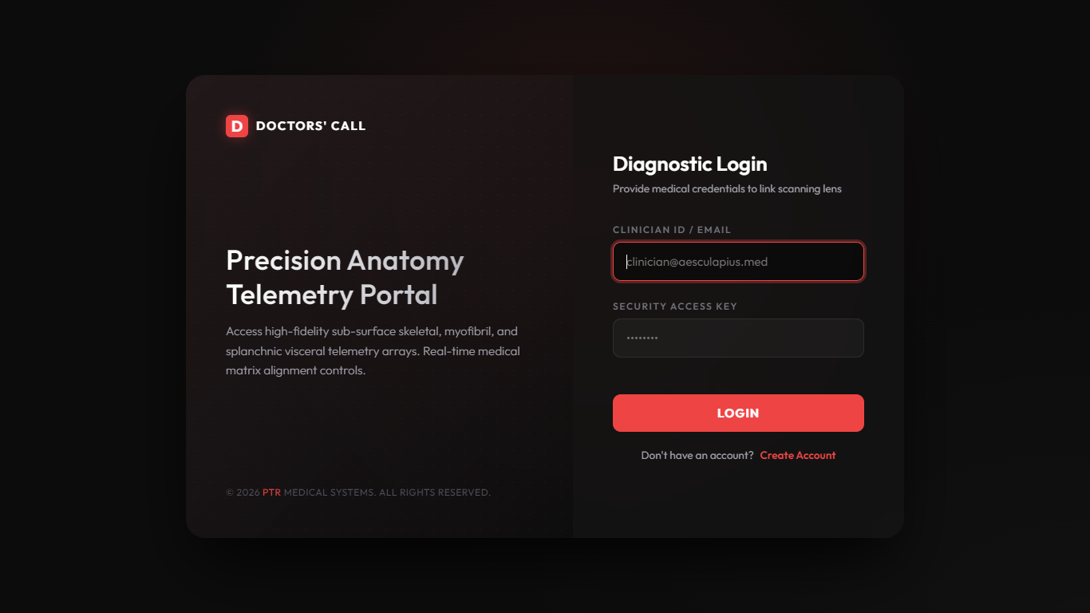
The Diagnostic Login interface verifies user credentials using JSON Web Tokens (JWT) and Bcrypt cryptographic hashing for maximum security. Users input their registered Clinician ID/Email and Security Access Key, prompting the backend to authenticate the session and link the scanning lens to their diagnostic profile. The layout is optimized for low-friction user experience with high-contrast inputs, ensuring rapid access to critical telemetry modules during emergencies.

Result Image: Clinician Diagnostic Profile Dashboard
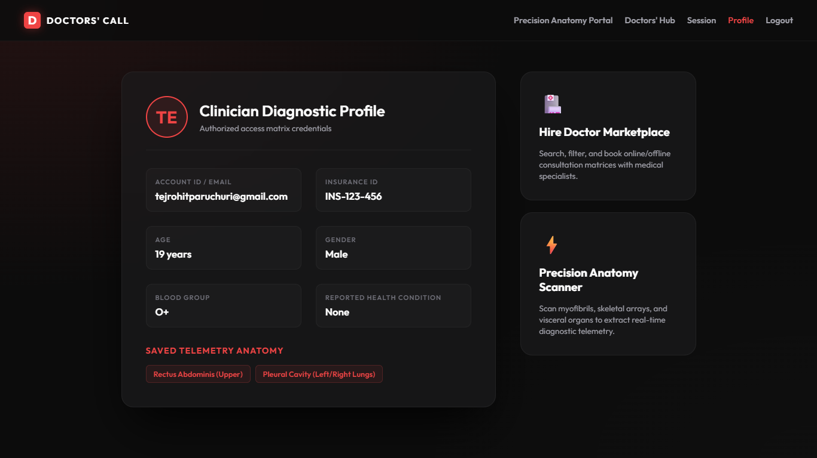
The Clinician Diagnostic Profile dashboard serves as the central hub for user profile information, personal telemetry settings, and saved anatomical scans. It displays key account credentials including Account ID, Insurance ID, age, gender, blood group, and reported health status, which form the base context for consultations. Additionally, it displays the user's saved telemetry anatomy records (e.g. Rectus Abdominis or Pleural Cavity) which are linked to active diagnostic sessions, enabling clinicians to easily retrieve past scans.

Result Image: Specialist Router and Marketplace
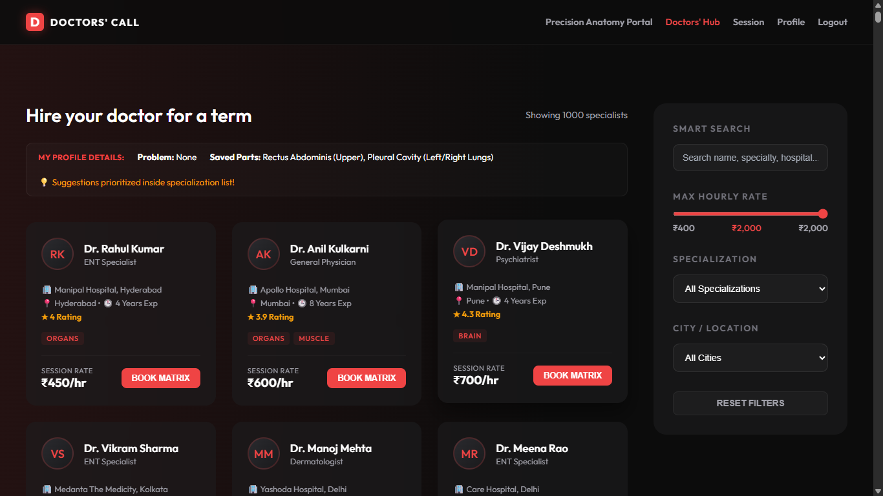
The 'Hire Doctor Marketplace' is a dynamic registry routing interface that displays the profiles of clinical specialists currently active on the platform. It shows search parameters, cities, specializations, hourly rates, and suggestions prioritized by the user's saved anatomy coordinate telemetry. Users can view specialist details, session rates, ratings, and click the 'Book Matrix' button to initiate an automated checkout billing flow for a consultation.

Result Image: Filtered Roster Registry
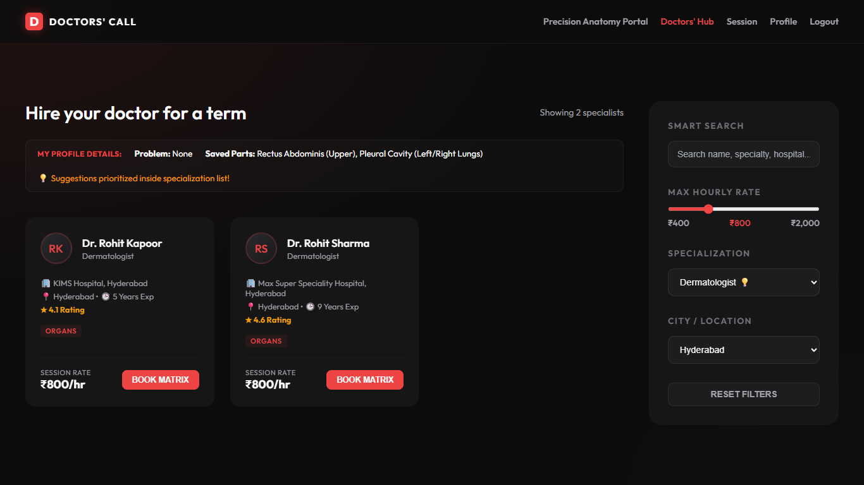
This view shows the Specialist Roster interface after applying search filters, demonstrating the backend routing capacity of the system. Users can filter by maximum hourly rate using a slider, specialization categories (e.g., ENT, General Physician, Psychiatrist), and geographical locations/cities. The interface dynamically displays the matching specialist profiles, allowing patients to select the most appropriate clinician based on cost, distance, and area of expertise.

Result Image: Interactive Sub-Surface Anatomical Scanner
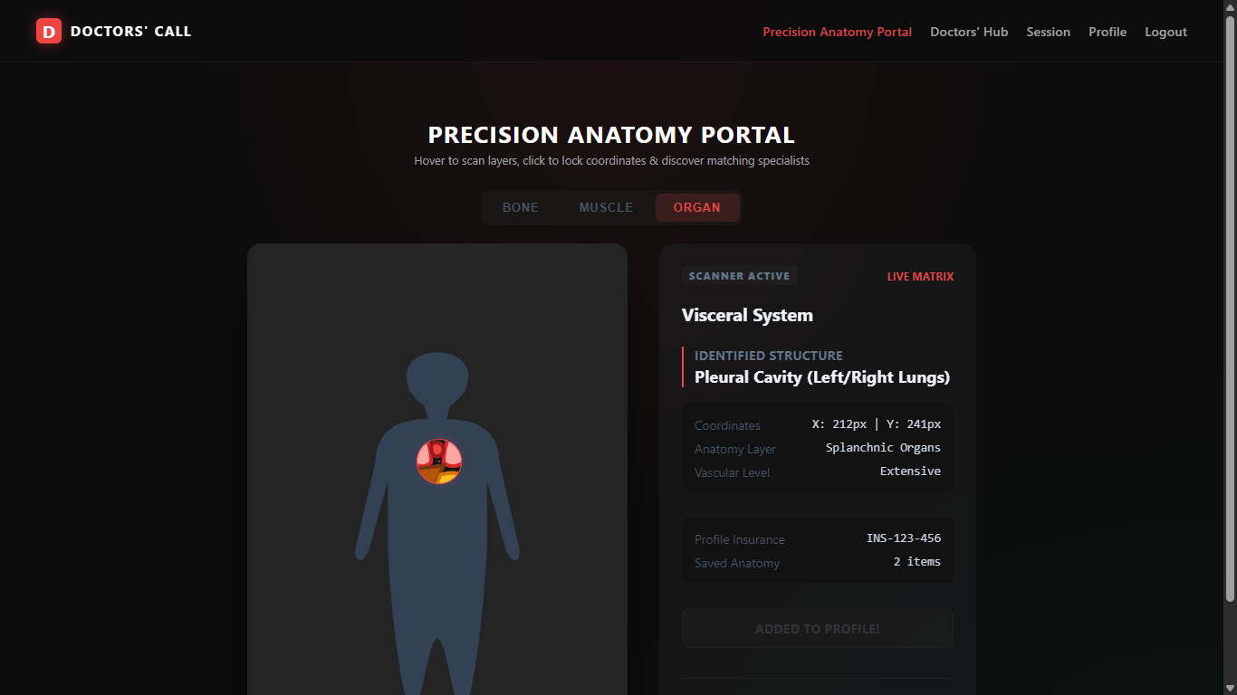
The interactive sub-surface anatomical scanner interface allows users to visualize skeletal structures, muscular arrays, and visceral organs using vector-based graphical telemetry. It captures user cursor coordinate movements and locks into specific anatomical coordinates to identify potential trauma or inflammation zones. The scanner dynamically routes focus areas to their corresponding medical specialties, creating a seamless diagnostic link between physical symptoms and clinical experts.

Result Image: Active Tele-Presence Session Console
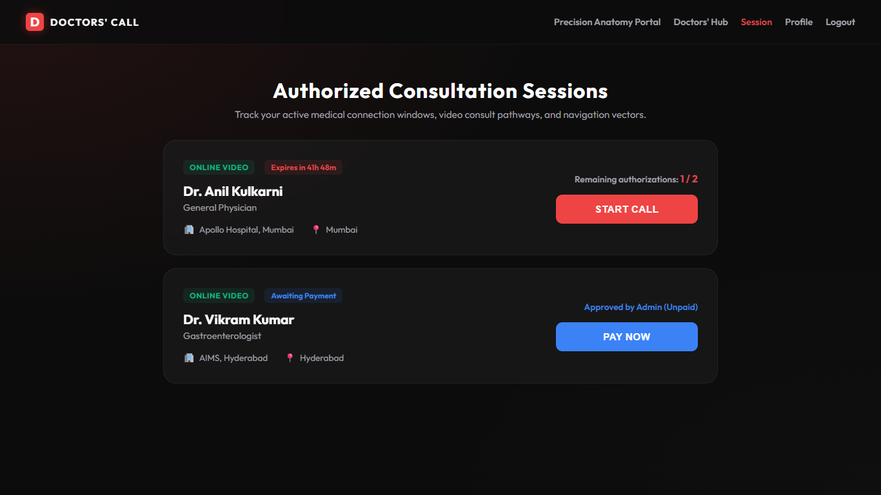
The Active Session console displays the status and metadata of current tele-presence consultation portals, monitoring the real-time decay of authorized access. It tracks parameters such as session expiration, maximum call allowance (limited to 2 active calls), and provides interactive triggers to initiate video/audio feeds. This module is protected by an automated backend chronometer that terminates session tokens exactly 48 hours post-checkout to optimize server resources.

Result Image: Clinical Tele-Presence Consultation Interface
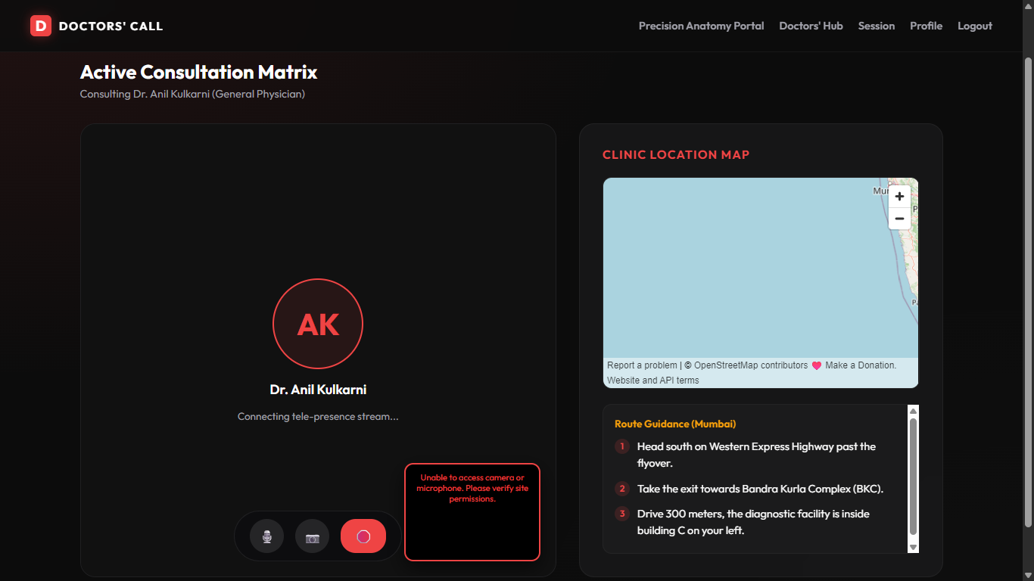
The active consultation page provides a real-time communication portal for clinicians and patients, facilitating chat messages, file sharing, and diagnostic coordination. It renders diagnostic checklists, historical telemetry scan overlays, and coordinates to allow the clinician to guide the patient during remote evaluations. The interface is designed with a premium, low-latency layout to ensure stable remote diagnostics even in low-bandwidth environments.

Result Image: Automated Checkout Billing Portal
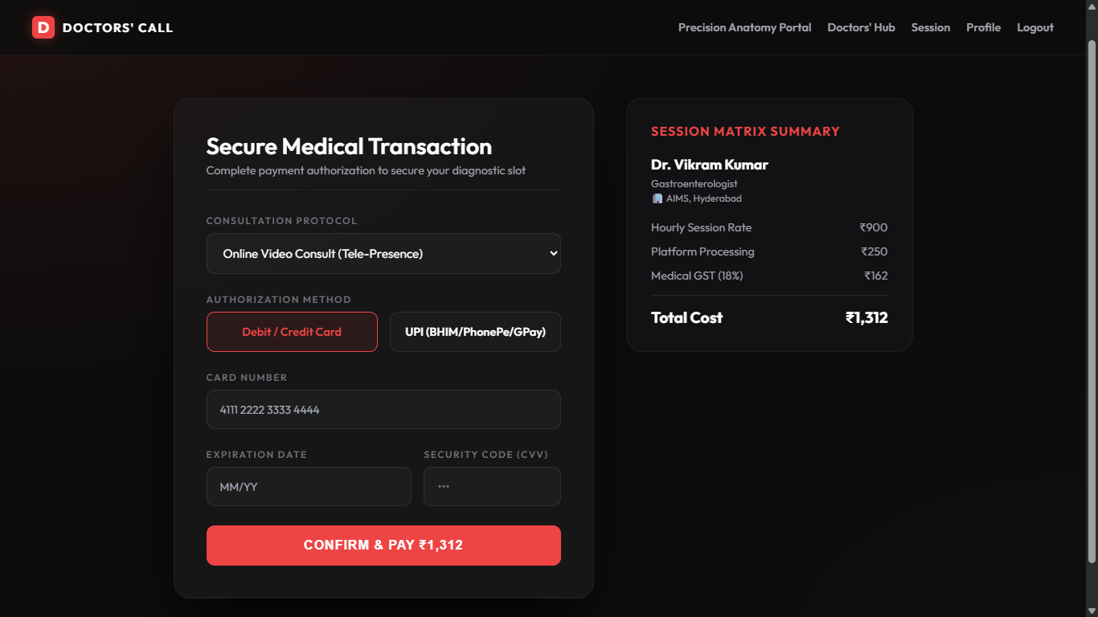
The checkout billing interface lists session parameters, selected specialist fees, and details the final billing breakdown including platform overhead fees and the 18% medical service tax. The layout is cleanly organized to display the patient's payment method, invoice reference codes, and billing calculations before authorizing the transaction. Successful checkout instantly initializes the 48-hour tele-presence session token and updates the administrative ledger.

Result Image: System Administration Control Panel
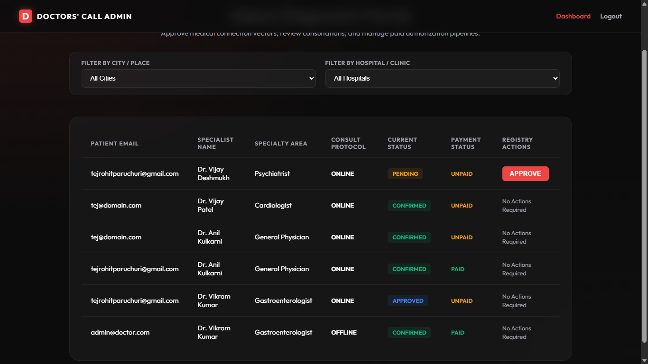
The system administration control panel provides system operators with comprehensive access to backend operations, system logs, and transaction data. It displays live billing analytics, registered user and clinician accounts, and active consultation session tokens, allowing administrators to monitor system performance. Administrators can manage specialist credentials, audit financial invoices, and ensure compliance with healthcare regulation metrics.

12. Known Issues
The table below lists identified operational limitations and their status:
Identified Limitation | Diagnostic Impact / Details | Resolution Strategy
Simulated consultations | The video interface uses text-chat simulation mockups. | Requires integration of active WebRTC sockets.
Local community persistence | MongoDB server defaults to local instances only. | Configure cloud cluster connections for deployment.

13. Future Enhancements
Planned improvements for future system releases are detailed below:
Planned Improvement | Technical Component | Operational Metric / Goal
Live consultation stream | WebRTC signalling sockets integration | Enable direct peer-to-peer visual and auditory consultations.
Medical standard compliance | HL7 and FHIR database schema alignment | Allows integration of patient data with EHR clinic systems.
Cross-platform mobile apps | React Native framework development | Enables iOS and Android deployments using native hardware.

